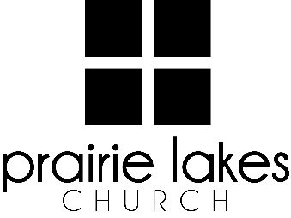

We are delighted you are considering an internship at Prairie Lakes Church! You can look forward to a challenging and rewarding year. Whether your passion is families, worship or administration, after spending a year with us, our goal is you will be more proficient with your skills, wiser as a leader and more mature as a follower of Christ.

**Overview:**

• You will be part of a cohort of 9-12 interns for the 2025-2026 academic year (August – May).

• You will be expected to invest a minimum of 10 hours per week during the semester.

• You will receive a stipend of $1600 per semester.

**Application Deadline:** February 21, 2025

Specific questions may be directed to Human Resources

internships@prairielakeschurch.org.

**Creative Media Intern**

Central Services

This intern will report to the Creative Media Director.

**Education, Experience and Skills Requirements:**

* Pursuing a degree from a four-year college or university
* Exhibit evidence of a healthy and growing relationship with Christ
* Fully support the ministry philosophy of Prairie Lakes Church and its leadership team
* Possess strong communication and IT skills
* Exhibit evidence of strong relational skills
* Possess a strong work ethic with a demonstrated ability to initiate and finish projects
* Experience with video production software a plus
* Comfortable with using video equipment
* Knowledge of Canva and Adobe Creative Cloud
* A love for engaging people through graphics and video on various content channels

**Responsibilities:**

* Assist with the pre-production of videos, projects, including contact the subject(s), scouting locations, and pre-interview meetings
* Record video/audio using various cameras, microphones, and audio recording equipment
* Edit video and deliver
* Travel to campuses to capture content
* Create simple graphics for events, promotion, and announcements
* Participate in Digital Strategies team meetings
* Write, direct, shoot, and edit short videos for social media markets
* Evaluate and enhance current media trends
* Assist with additional projects and tasks as needed

**Development:**

* Personalized leadership coaching & development meetings
* One-on-one mentoring
* Personalized StrengthsFinder coaching
* Exposure to all Prairie Lakes Church campuses
* Fall retreat