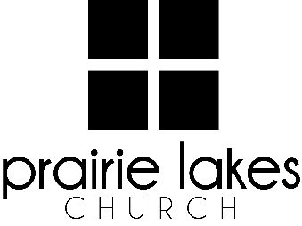

We are delighted you are considering an internship at Prairie Lakes Church! You can look forward to a challenging and rewarding year. Whether your passion is families, worship or administration, after spending a year with us, our goal is you will be more proficient with your skills, wiser as a leader and more mature as a follower of Christ.

**Overview:**

• You will be part of a cohort of 9-12 interns for the 2025-2026 academic year (August – May).

• You will be expected to invest a minimum of 10 hours per week during the semester.

• You will receive a stipend of $1600 per semester.

**Application Deadline:** February 21, 2025

Specific questions may be directed to Human Resources

internships@prairielakeschurch.org.

**Human Resources Intern**

Central Services

This intern will report to the Human Resources Director.

**Education, Experience and Skills Requirements:**

* Pursuing a degree from a four-year college or university
* Exhibit evidence of a healthy and growing relationship with Christ
* Fully support the ministry philosophy of Prairie Lakes Church and its leadership team
* Possess strong communication and IT skills
* Exhibit evidence of strong relational skills
* Possess a strong work ethic with a demonstrated ability to initiate and finish projects
* Possess a strong understanding of the Prairie Lakes Church culture
* Possess strong leadership and shepherding skills
* Previous PLC internship experience is beneficial

**Responsibilities:**

* Assist in planning and coordinating PLC internship events and activities
* Act as the liaison between the intern cohort and Human Resources and supervisors as needed
* Participate in the distribution of books, articles and assessments to interns throughout the year
* Assist in tracking of intern experiences and completion of checkpoints throughout the year
* Assist with various human resources needs
* Plan intern fall retreat activities and location
* Plan visits to all Prairie Lakes Church campuses

**Development:**

* Personalized leadership coaching & development meetings
* One-on-one mentoring
* Personalized StrengthsFinder coaching
* Exposure to all Prairie Lakes Church campuses
* Fall retreat